jQuery

**DEADLINE:** 08/04/2018

## FOLDER STRUCTURE

Homework_07/

├─ styles/

├─ style.css

├─ img/

├─ js/

├─ jquery-3.3.1.min.js

├─ index.js

└─ index.html

## TASK

Create one variation of game Gomoku(Go) - free-style Gomoku(pic. 1). Free-style gomoku requires a row of **4** or more stones for a win.

**Requirements**:

* Go-board size 15 x 15(grid);
* position for stones it’s intersection of lines;
* players make moves in turn;
* create labels ‘Black’ and ‘White’(stones colors) above the board and highlight label of next stone;
* row of **4** or more stones for a win(horizontal, vertical, diagonal), highlight the winning row and show message for players.

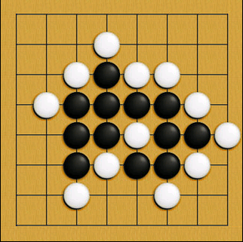

##### Pic. 1 — Gomoku example.

## RESTRICTIONS

* jQuery source files shouldn't be touched at all;
* no need to use any of build systems(grunt, gulp, webpack).

## BEFORE SUBMIT

* test the game;
* check files structure;
* check code structure(code style);

## USEFUL LINKS

* <https://en.wikipedia.org/wiki/Gomoku>
* <https://code.jquery.com/jquery-3.3.1.min.js>